Game Design Document

**2015**

Shrey Kachhap

Cenzy

11/13/2015

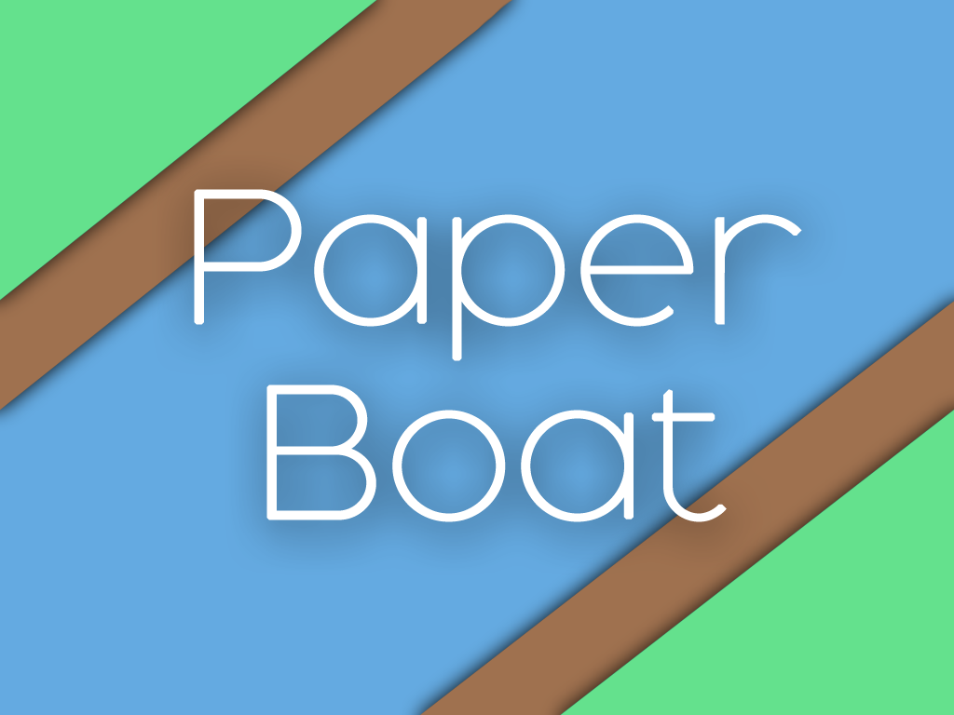

Contents

Change log 2

Version 1.0 (17 November 2015) 2

Version 2.0(18th November 2015) 2

Overview 3

Genre 3

Target Audience 3

Gameplay 3

Objective 3

Mechanics 3

Gameplay 3

Game over 4

Revive 4

Pay Slips 4

Watch Video Add 4

Level Progression 4

Difficulty 4

Aesthetically 4

Scoring System 5

Distance 5

Slips 5

Total Score = Distance travelled + No. of Slips collected 5

Visual Effects 5

Slips Collection 5

Fail 5

User interface 5

User interface 6

Main Menu 7

Play Button 7

Quit 7

Gameplay 7

Shop 8

Slips 8

Buy Slips 8

Boats 8

Environments 8

Challenges 10

Slip Collection 10

Gameplay 10

Combo 10

Controls 11

Ripple 11

Asset List 12

Environment 12

# Change log

### Version 1.0 (17 November 2015)

### Version 2.0(18th November 2015)

Added Change log

Added asset list

Added Game Over tab in UI Flow Chart

# Overview

Paper Boat is an endless runner for mobile targeted to the audience of all ages. As the name says, the game focuses on a Paper boat’s Journey to infinity. The Paper Boat dodges through a variety of obstacles while travelling down a brook engaging the player to experience a medium paced gameplay with simplistic, soothing and vibrant Environmental Graphics.

# Genre

Endless Runner

# Target Audience

All ages, Casual gamers

# Gameplay

The gameplay starts from a brook where a small child releases a paper boat that will float along the brook all the way to where the waters meet far away. Player has to tap on the water body to create ripples. The ripples force the boat to move away from the centre. Player should try to avoid running into obstacles which will cause the paper boat to get stuck and the camera continues to move forward. If the Boat is left behind and goes out of the scene, the game gets over.

# Objective

The main objective of ‘Paper Boat’ will be to score higher. Though the player does a lot of other stuffs to in the game like buys new boats, themes and accomplish various Achievements(integrated to Google accounts), the target is to compel the player to focus on one’s score and have a sense of competition.

# Mechanics

## Gameplay

|  |  |  |
| --- | --- | --- |
| **Paper Boat**  **(Character)** | Main Subject of the game  Floats continuously along the brook  Cannot drown | |
| **Ripples**  **(Control Mechanics)** | Created by tapping on the screen  Pushes the boat away from itself  Does not have a count limit | |
| **Obstacles** | Lily Pad | Static on brook, normal obstruction |
| Duck | Slowly moving in opposite direction |
| Fish | Fast moving in random directions |
| Island | Static on brook, partially obstructs boat in an area aound |
| Bridge | Player cannot tap on the water underneath |
| Cataract | Pushes the boat away |
| **Collectibles** | Slips | In Game Currency |
| **Game Over** | Revive | Gives the player another chance |
|  | Quit | Goes to main menu |

## Game over

The boat gets obstructed by the objects on the brook but the camera still continues to move.

As soon as the boat moves out of the camera, Everything fades to black and the game over pop-up appears With revive and home options.

## Revive

### Pay Slips

|  |  |
| --- | --- |
| Revive | Cost (Slips) |
| 1st revive | 200 |
| 2nd revive | 500 |
| 3rd revive | 1000 |

### Watch Video Add

This can be used only once. Player has to watch a 15 sec video to revive.

# Level Progression

Well the game is endless, hence we cannot have a number of levels in the game but there will be sets of variable difficulty that alters the gameplay for the player throughout the game so that the player does not get bred after playing the game for too long.

## Difficulty

|  |  |
| --- | --- |
| **Set 1** | Default Speed |
| 1min | This is the speed with which the game begins. |
| Obstacles | Default frequency |

|  |  |
| --- | --- |
| **Set 2** | High Speed |
| 1min | Gives better scores, but tough to complete. |
| Obstacles | Less frequency |

|  |  |
| --- | --- |
| **Set 3** | Slow Speed |
| 30 sec | Gives low scores but this is the set where the player is relaxed for a few seconds. |
| Obstacles | High frequency |

## Aesthetically

We want the player to experience a change throughout the game.

|  |  |
| --- | --- |
| Day | Default lighting |
| Dusk | Orange tone |
| Night | Dark Purplish tone |
| Jugnu Particles |
| Dawn | Purplish + orange tone |

# Scoring System

## Distance

This is the Basic Score Unit. Total distance is calculated in meters with decimal points.

## Slips

Slips are the Collectibles. These are dropped randomly during the journey according to the Drop Rate of the environment.

## Total Score = Distance travelled + No. of Slips collected

# Visual Effects

### Slips Collection

Whenever the player collects a slip, a particle system appears.

### Fail

When the boat is left behind, the screen gets faded to black. And then the level failed popup appears with a fade in effect.

### User interface

We will be using single scene for all the UI screens.

The Main Menu is the gameplay Screen itself.

# User interface

|  |  |  |
| --- | --- | --- |
| **Main Menu** | Play | Goes to Gameplay screen |
| Quit | Quits the Game |
| Shop | Takes the player to the Shop Screen |
| Achievements | List of all achievements accomplished and unacomplished |
| **Shop** | Total Slips | Used to buy items |
| Boat | Can be bought Using Slips |
| Environment | Can be bought Using Slips |
| **Challenges** | Slip Collection wise | Player gets rewarded with slips and Google achievements |
| Gameplay wise | Player gets rewarded with slips and Google achievements |
| **Pause** | Resume | Resume Game |
| Home | Goes to main Menu |
| **Game Over** | Revive using Slips | Costs some amount of Slips |
| Revive Using Video Ad | Watch 1 video ad to revive |
| home | Goes to main Menu |
| Share(Pop-up) | Share through Facebook to gain more slips |



## Main Menu

*The main menu has no settings button since the game has no complicated systems. If the player wants to decrease the volume, he can use the default volume keys to reduce the device’s system volume.*

*Any other screen*

### Play Button

Directly takes the player to the gameplay screen.

A small cute girl child holding a paper boat stands beside the brook, asking the player for help.

Agreeing to help the Child is the Play button.

### Quit

Exits the Game by asking for a confirmation.

## Gameplay

When the player presses the Play Button, The Child places the Boat on the brook and the player can then control the Boat.

## Shop

Slips- this is the in-game currency.

|  |  |
| --- | --- |
| **Total Slips** | This Will Show the Total No. of slips Obtained after login |
| Click on the Button to Buy More Slips |
| **Boats** | Buy new boats using Slips |
| Every new boat has an increased score multiplier |
| **Environments** | Buy new environments using Slips |
| Very costly but have a very Big advantage |

### Buy Slips

|  |  |
| --- | --- |
| **No. of slips** | **Cost** |
| 700 | 49 Rs |
| 1600 | 99 Rs |
| 3500 | 199 Rs |
| 7000 | 299 Rs |

### Boats

|  |  |  |
| --- | --- | --- |
| **Boat** | **Cost (Slips)** | **Advantage** |
| Boat 1 | Free | Default Boat 1x Multiplier |
| Boat 2 | 500 | 1.2x Multiplier |
| Boat 3 | 1000 | 1.4x Multiplier |
| Boat 4 | 1500 | 1.6x Multiplier |
| Boat 5 | 2500 | 1.8x Multiplier |
| Boat 6 | 6000 | 2.0x Multiplier |
|  |  |  |

### Environments

|  |  |  |
| --- | --- | --- |
| **Environment** | **Cost** | **Slips Drop Rate** |
| Default | 1000 | 1 per 6 seconds |
| Snow | 2500 | 2 per 6 seconds |
| Arid | 7000 | 3 per 6 seconds |

* *The images shown below are for a rough idea of how the Menu Screens will look.*
* *Fonts and image (with Proper colours) will be used according to the Objects placed in the scene to make the UI more User friendly.*
* *All fonts used in the Canvas will be Unity Font itself. This will save memory.*

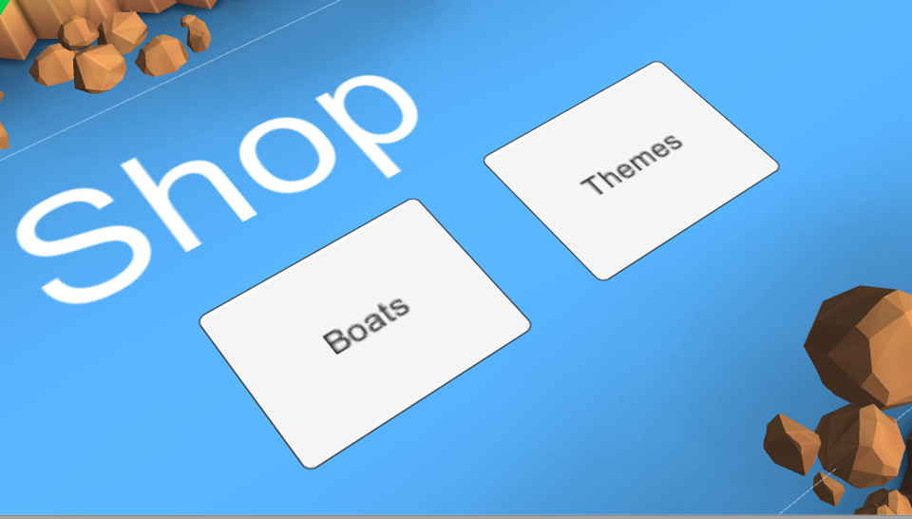

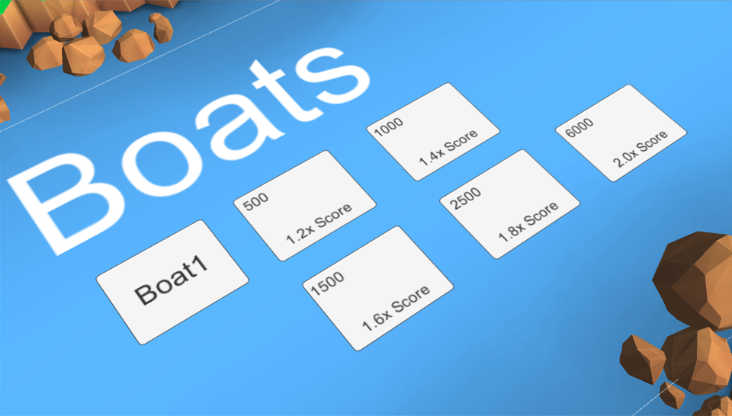

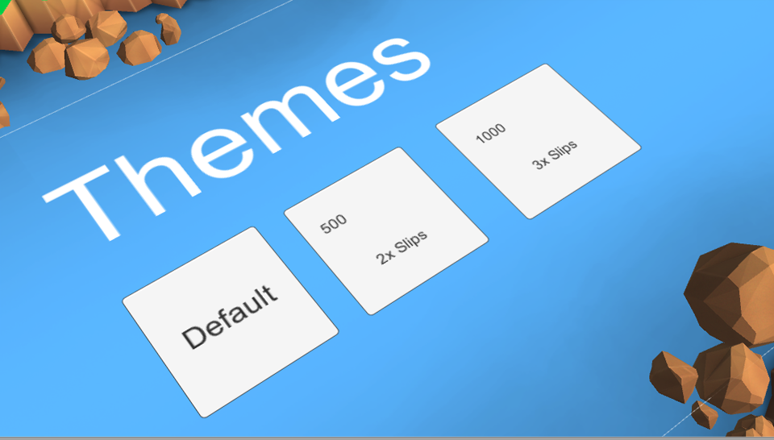

# Challenges

### Slip Collection

* Player will be rewarded according to the number of slips collected in one run
* Reward will be shown in a wrapped Craft paper that unwraps on tapping.

|  |  |
| --- | --- |
| **Collection** | **Reward** |
| 50 | 50 slips |
| 100 | 120 slips |
| 200 | 250 slips |
| 500 | 700 slips |

### Gameplay

* Player will be rewarded according to the way the game is played.
* Reward will be shown in a wrapped Craft paper that unwraps on tapping.

|  |  |
| --- | --- |
| **Task (in one run)** | **Reward** |
| Complete 20m without colliding | 50 slips |
| Complete 50m without colliding | 150 slips |
| Complete 75m without colliding | 250 slips |
| Cross 50m without revive | 100 slips |
| Cross 75m without revive | 200 slips |
| Cross 100m without revive | 400 slips |
| Collide with 15 objects without revive | 100 slips |
| Collide with 25 objects without revive | 150 slips |
| Collide with 40 objects without revive | 200 slips |

### Combo

|  |  |
| --- | --- |
| Task **(in one run)** | Reward (slips) |
| Collect 50 slips without colliding | 100 |
| Collect 70 slips without colliding | 200 |
| Collect 100 slips without colliding | 350 |
| Collect 500 slips without colliding | 600 |
| Collect 50 slips without reviving | 120 |
| Collect 70 slips without reviving | 150 |
| Collect 100 slips without reviving | 200 |
| Collect 500 slips without reviving | 300 |

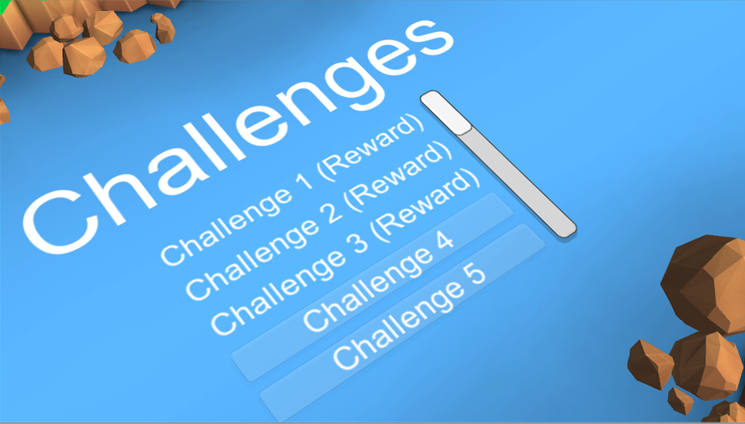

# Controls

The only verb in the Game is ‘Tap’.

1 tap on the water body creates a ripple that pushes the boat with a force directed from the ripple’s centre towards the centre of the boat.

### Ripple

* Created when tapped on screen. Holding or releasing does not to anything.
* Ripple has maximum force at the centre and this decreases towards the circumference as the ripple expands.
* The boat should be pushed only when the ripple touches the boat while expanding

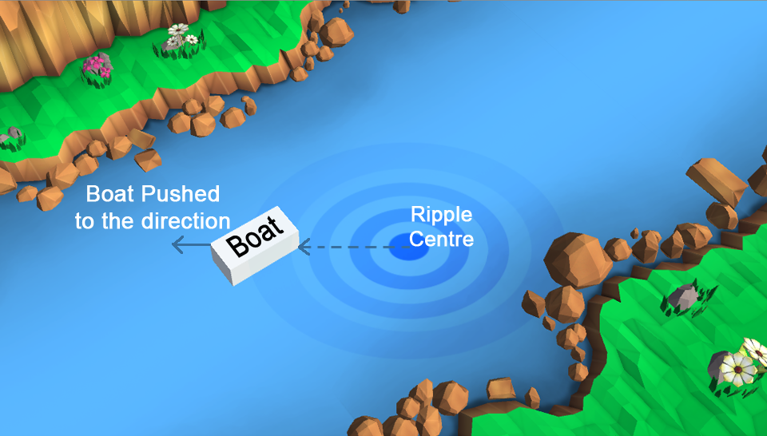

# Asset List

## Environment

These objects will be placed on the scene as static objects

|  |  |
| --- | --- |
| 1. water | The area where the boat will flow |
| This is the reason the boat runs |
| 1. Right bank | Lies in the right side of the water |
| 1. Left bank | Lies in the right side of the water |
| 1. Brown Rocks 3 variants | These will be along the banks |
|  | Have colliders and can obstruct the boat from floating with the brook |
| 1. Grey Rock | Will be placed on the banks |
| 1. Grass | Will be placed on the banks |
| 1. Flower | Will be placed on the banks |
| 1. Cliff | Will be placed on the left edge of the Left Bank |
| 1. Bridge | Crosses from Left to Right Bank |
| 1. Slant | Will be replaced by cliffs for bridge |
| 1. Cataract | Flows from the cliff down to the brook(perpendicular) |

## Obstacles

These objects will be generated randomly on the asset “Water”. They have colliders

|  |  |
| --- | --- |
| Lily Pad |  |
| Island |  |
| Fish |  |
| Duck |  |

### Lily Pad

A static floating object placed randomly on the water.